

SMART-BRIDGE INTERNZ ORGANIZATION

SAMHITHA DEGREE COLLEGE

TEAM MEMBERS:-

VASAMSETTI SHARMILA DEVI (2300928200030)

AKSHINTHALA SANTOSH KUMAR(200928200002)

KARRI PRAVEEN KUMAR (2300928200019)

VEENAM SRINIVAS RAO(200928200031)

BALASA VIKAS (200928200004)



INTRODUCTION

Fabindia is a renowned Indian retail brand that has gained popularity for its unique and sustainable approach to fashion and lifestyle products. Established in 1960 by John Bissell, Fabindia started as an export company that aimed to promote traditional Indian handloom and craft traditions, while also providing economic opportunities to rural artisans and weavers.

The brand's core philosophy revolves around celebrating the richness and diversity of India's cultural heritage by incorporating traditional craftsmanship into contemporary designs. Fabindia's product range includes a wide array of clothing, accessories, home furnishings, and personal care items, all of which are crafted using traditional techniques and natural materials.

One of Fabindia's key strengths lies in its commitment to promoting ethical practices and supporting local communities.

By collaborating with artisans from remote villages and marginalized communities across India, the brand empowers these craftsmen and women by providing them a platform to showcase their skills and preserve their heritage.

Fabindia's products are not only known for their exquisite craftsmanship but also for their sustainable and environmentally friendly approach

. The brand emphasizes the use of natural and organic materials, ensuring minimal impact on the environment and promoting a more responsible way of consuming fashion and lifestyle products.

Over the years, Fabindia has evolved into a leading retail player in India, with stores not only across the country but also in international markets.

Its success can be attributed to the growing global interest in sustainable and ethical products, as well as the increasing appreciation for India's diverse cultural traditions.

Overall, Fabindia has become a symbol of Indian artistry, sustainability, and responsible consumerism, attracting customers who value tradition, craftsmanship, and the promotion of social welfare.

Send a messFabindia is a renowned Indian retail brand that has gained popularity for its unique and sustainable approach to fashion and lifestyle products.

Established in 1960 by John Bissell, Fabindia started as an export company that aimed to promote traditional Indian handloom and craft traditions, while also providing economic opportunities to rural artisans and weavers.

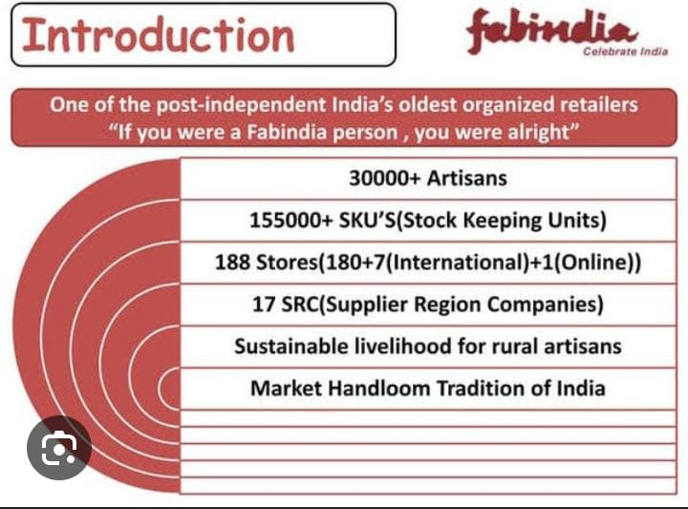

# OVERVIEW:-

As of my last update in September 2021, Fabindia had established itself as a prominent and well-respected retail brand with a strong presence in India and certain international markets

. Let's provide an overview of Fabindia based on the information available up to that point:

Product Range: Fabindia offers a diverse range of products that reflect India's cultural heritage and craftsmanship.

The brand is particularly known for its handwoven textiles, traditional clothing like kurtas, sarees, and shawls, as well as home furnishings such as bed linens, tableware, and home décor .

# PURPOSE:-

The purpose of Fabindia revolves around several core principles and values that guide its business approach and operations. Some of the key purposes of Fabindia are

Preserving Indian Cultural Heritage: Fabindia's primary purpose is to celebrate and preserve India's rich cultural heritage, particularly its traditional craftsmanship and handloom techniques

. By incorporating these age-old practices into modern designs, Fabindia helps keep these traditions alive and relevant in the contemporary world.

Empowering Rural Artisans: Fabindia is committed to empowering rural artisans and craftsmen by providing them with a sustainable livelihood.

The brand collaborates directly with artisans, weavers, and craftspeople from various remote villages and marginalized communities, offering them fair wages and support for skill development.

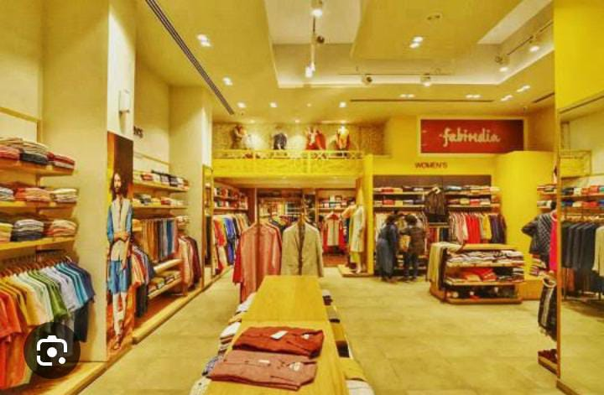

LITERATURE SURVEY

Company Reports and Publications: Fabindia's own reports, publications, and official statements can provide insights into their business strategies, expansion plans, and corporate social responsibility initiatives. These might include annual reports, sustainability reports, and press releases.

Academic Papers and Case Studies: Researchers and scholars in the fields of business, fashion, sustainability, and social entrepreneurship may have conducted studies or written case analyses on Fabindia's business model, impact on rural artisans, and its sustainable practices.

News Articles and Media Coverage: There are likely to be various news articles and media features about Fabindia, covering topics such as new product launches, store openings, collaborations, and its role in promoting traditional Indian crafts.

Fashion and Lifestyle Magazines: Fabindia's products, especially its clothing and home furnishings, are often featured in fashion and lifestyle magazines. These publications might provide insights into Fabindia's design aesthetics and its position in the fashion industry

Books and Industry Publications: Some books focusing on Indian fashion, crafts, and sustainable business practices may include sections or chapters about Fabindia and its contribution to the industry.

Consumer Reviews and Blogs: People who have purchased Fabindia products often share their experiences and reviews on blogs and social media platforms, providing a glimpse into customer perceptions and satisfaction.

Ethical and Sustainable Fashion Publications: Fabindia's commitment to ethical sourcing and sustainable practices may have earned it a place in publications dedicated to eco-friendly and socially responsible fashion brands.

When conducting a literature survey, it's essential to use academic databases, library resources, and online platforms to access credible sources. If you're looking for the most recent information, make sure to search for articles and publications published after my knowledge cutoff date of September 2021.

EXISTING PROBLEM :-

Supply Chain and Quality Control: Fabindia sources its products from various rural artisans and weavers across India. Ensuring consistent quality across a diverse supply chain can be challenging. Maintaining quality standards, especially when working with traditional handmade products, may be an ongoing concern.

Competition from Fast Fashion Brands: The rise of fast fashion brands, both domestic and international, may pose a challenge for Fabindia. These brands often offer trendy and inexpensive options, which can lure customers away from Fabindia's more sustainable and artisanal products.

Price Sensitivity: Some consumers might perceive Fabindia's products as relatively higher priced compared to mass-produced alternatives. Convincing price-sensitive customers about the value of handmade and sustainable products could be a persistent challenge.

Expansion and Market Penetration: As Fabindia expands its retail footprint and reaches into new markets, it may face challenges in understanding and adapting to local consumer preferences and cultural differences.

Online Competition: The growth of e-commerce and online marketplaces has intensified competition in the retail space. Fabindia needs to maintain a strong online presence and offer a seamless shopping experience to remain competitive in the digital market.

Sustainability and Environmental Impact: While Fabindia emphasizes sustainability, there might still be areas where the brand can further improve its environmental practices, such as reducing its carbon footprint and exploring alternative eco-friendly materials.

Balancing Tradition and Modernity: As Fabindia aims to preserve traditional Indian crafts while staying relevant in contemporary fashion and lifestyle trends, finding the right balance between tradition and modernity can be an ongoing challenge.

It's important to note that the information provided is based on the state of Fabindia up until September 2021. Since then, the company might have made efforts to address some of these issues or may be facing new challenges. For the most current and accurate information, I recommend referring to Fabindia's official website, recent news articles, and other reliable sources.

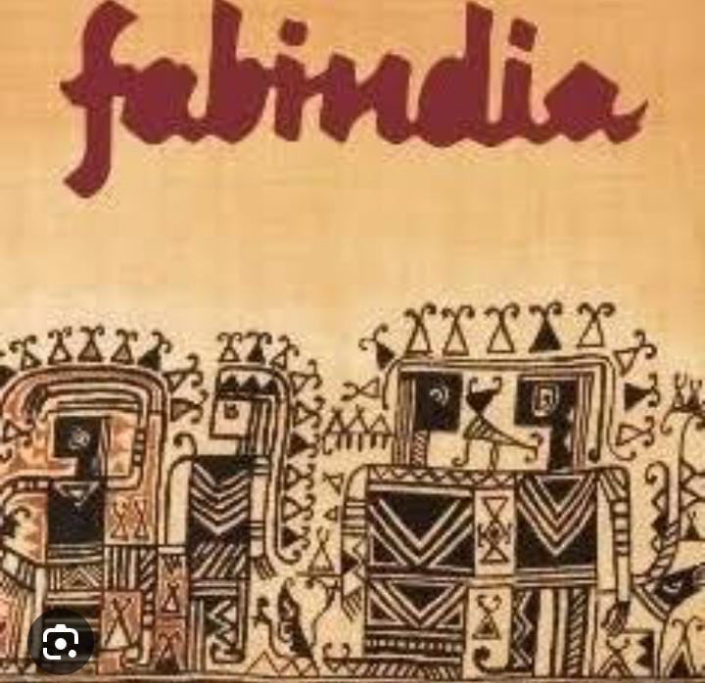

## PROPOSED SOLUTIONS:-

Quality Control and Supply Chain Management: Invest in robust quality control measures and work closely with artisans to maintain consistent product quality. Implement training programs and workshops to enhance the skills of the craftsmen, ensuring high-quality products throughout the supply chain.

Innovation and Design: Continuously innovate and experiment with designs to keep up with changing fashion trends while preserving traditional craftsmanship. Collaborate with contemporary designers to create unique and appealing collections that resonate with a broader audience.

Competitive Pricing Strategy: Develop a pricing strategy that highlights the value of handmade and sustainable products, ensuring that consumers understand the benefits of supporting artisans and the environment through their purchases.

Customer Education and Engagement: Educate customers about the cultural significance and craftsmanship behind Fabindia's products. Engage with customers through social media, workshops, and events to build a deeper connection with the brand.

Digital Transformation: Enhance the online shopping experience by improving the user interface of the website and investing in e-commerce technologies. Offer online exclusives and promotions to attract and retain digital-savvy customers.

Sustainable Initiatives: Strengthen Fabindia's commitment to sustainability by implementing more eco-friendly practices throughout its operations. This may include reducing plastic packaging, exploring alternative sustainable materials, and promoting eco-conscious lifestyles.

Market Research and Local Adaptation: Conduct thorough market research before entering new markets to understand consumer preferences and cultural nuances. Tailor product offerings and marketing strategies to resonate with local audiences.

Community Outreach and Social Impact: Continue to invest in social development initiatives that support the communities of artisans and weavers. Showcase the positive social impact of Fabindia's work to build a stronger brand reputation.

THEORITICAL ANALYISIS:-

Theoretical analysis of Fabindia involves examining the brand's key principles, strategies, and practices through the lens of various business theories and frameworks. Here, we'll explore Fabindia's approach using some common theoretical perspectives:

Social Entrepreneurship: Fabindia embodies the principles of social entrepreneurship, which focus on creating positive social impact while operating as a sustainable business. The brand's core mission of preserving Indian traditional crafts and empowering rural artisans aligns with the social entrepreneurship theory. Fabindia's business model demonstrates how a profit-driven organization can play a crucial role in addressing social challenges and promoting inclusive growth.

Sustainable Business Practices: Fabindia's commitment to sustainability can be analyzed using the framework of sustainable business practices. The brand's emphasis on eco-friendly materials, ethical sourcing, and fair trade aligns with the principles of sustainable development. By incorporating these practices into its operations, Fabindia showcases how businesses can contribute to environmental conservation and responsible consumption.

Value Chain Analysis: Applying value chain analysis to Fabindia's operations can reveal the various activities that contribute to its competitive advantage. The direct engagement with artisans and weavers, along with the in-house design and product development, helps create unique, handcrafted products, differentiating Fabindia from mass-produced alternatives.

Resource-Based View (RBV): The RBV theory can be used to understand Fabindia's competitive advantage in terms of its resources and capabilities. The brand's extensive network of rural artisans, access to traditional craftsmanship, and strong brand reputation are valuable resources that contribute to its success.

Corporate Social Responsibility (CSR): Fabindia's CSR initiatives align with the theory of corporate social responsibility. The brand's focus on supporting artisans, preserving cultural heritage, and promoting sustainable practices goes beyond profit maximization and demonstrates a sense of responsibility towards society and the environment.

# BLOCK DIAGRAM :-

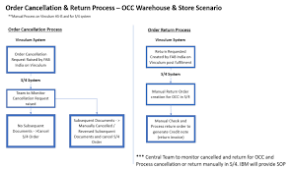 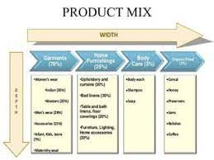

The core of Fabindia's business is built upon traditional crafts and artisanal products.These traditional crafts are blended with modern designs to create unique and contemporary offerings.Sustainable materials are used in the production process to promote eco-friendly practices.Ethical sourcing ensures fair wages and working conditions for artisans and weavers.

The brand's commitment to empowering artisans and supporting rural communities is a central pillar of its business model.

Fabindia places a strong emphasis on social and environmental responsibility, contributing to a positive impact on society and the planet.A growing customer base is attracted to Fabindia's unique products and ethical practices.

By incorporating these elements, Fabindia achieves profitability and sustains its growth as a socially responsible and sustainable retail brand.Please note that this is a simplified representation, and the actual operations and structure of Fabindia may involve more complexities and additional components.

# HARDWARE / SOFTWARE DESIGNING:-

### Software Design for Fabindia:

a. Inventory Management System: Fabindia likely uses an inventory management system to track their vast array of products, manage stock levels, and ensure efficient restocking.

b. Point of Sale (POS) System: To facilitate sales in their retail stores, Fabindia might utilize a POS system that handles customer transactions, tracks sales, and manages payment processing.

c. Customer Relationship Management (CRM): A CRM system helps Fabindia manage customer data, preferences, and interactions, enabling personalized marketing and customer service.

d. E-commerce Platform: If Fabindia operates an online store, they would require an e-commerce platform to handle online orders, payments, and customer support.

e. Supply Chain Management: Fabindia may use software to optimize their supply chain, from sourcing raw materials to delivering finished products to stores and customers.

f. Accounting Software: For financial management, Fabindia likely uses accounting software to handle bookkeeping, invoicing, payroll, and financial reporting.

g. Business Intelligence and Analytics: Fabindia might employ data analytics tools to gain insights into sales trends, customer behavior, and inventory performance.

### Hardware Design for Fabindia:

a. Point of Sale (POS) Terminals: In their retail stores, Fabindia would use POS terminals equipped with barcode scanners and payment processing capabilities.

b. Servers and Data Storage: Fabindia needs servers and data storage solutions to host their software systems and store critical business data securely.

c. Networking Infrastructure: To ensure seamless communication between various stores, warehouses, and the central office, Fabindia would require a robust networking infrastructure.

d. Security Systems: To protect their physical stores and digital assets, Fabindia might deploy security systems, including surveillance cameras and access control mechanisms.

e. Mobile Devices: For mobile sales, inventory management, and customer interactions, Fabindia employees may use tablets or other handheld devices.

RESULT

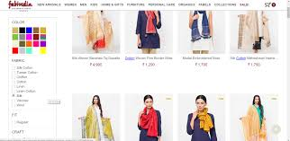

As of my last knowledge update in September 2021, Fabindia is a well-known Indian retail chain that specializes in ethnic wear and traditional crafts. They offer a wide range of products, including clothing for men, women, and children, home furnishings, personal care products, and accessories.

Since my information might be outdated, I recommend checking the latest news or visiting their official website to get the most current and accurate information about Fabindia and their products.

# ADVANTAGES AND DUISADVANTAGES:-

### ADVANTAGES:-

Ethical Sourcing: Fabindia is committed to promoting traditional crafts and artisans from rural areas by sourcing their products directly from them. This approach supports local communities and helps preserve traditional craftsmanship.

Unique and Authentic Products: The products offered by Fabindia often showcase a blend of contemporary designs with traditional craftsmanship. Customers appreciate the authenticity and uniqueness of the items, which are not easily found in mass-produced goods.

Sustainable and Eco-Friendly: Fabindia's emphasis on traditional crafts often involves the use of natural materials and sustainable production methods, making their products environmentally friendly.

Diversity of Products: Fabindia offers a wide range of products, including clothing, home furnishings, personal care items, and accessories, catering to different customer preferences and needs.

Cultural Heritage: By supporting traditional crafts and artisans, Fabindia helps preserve India's rich cultural heritage and promotes the continuation of age-old techniques.

Social Impact: The company's sourcing model has a positive impact on the livelihoods of rural artisans and craftsmen, providing them with a market for their products and empowering them economically.

### DISADVANTAGES:-

Higher pricing: Fabindia's products are often considered premium and may be more expensive compared to similar products available in the market. This pricing strategy can make it less accessible to budget-conscious customers.

Limited range of products: While Fabindia offers a diverse selection of traditional and handcrafted items, the range might not cater to all consumer needs. Customers seeking modern or contemporary styles may find the selection limited.

Availability: Fabindia stores may not be present in all locations, particularly in smaller towns and rural areas, making it less convenient for some customers to access their products.

Repetitive designs: Some critics argue that Fabindia's designs can become repetitive, lacking significant variation in styles and patterns, which might make the shopping experience monotonous for some customers.

Competition: The market for traditional handcrafted products and clothing in India is competitive, with numerous local and regional players offering similar products. Fabindia faces competition from various other brands and artisanal outlets.

Ethical concerns: While Fabindia claims to support artisans and rural communities, there have been occasional concerns regarding the fair wages and working conditions of the artisans involved in the production process.

Sustainability concerns: Though Fabindia promotes handcrafted and eco-friendly products, there have been debates about whether their practices are genuinely sustainable or merely marketed as such.

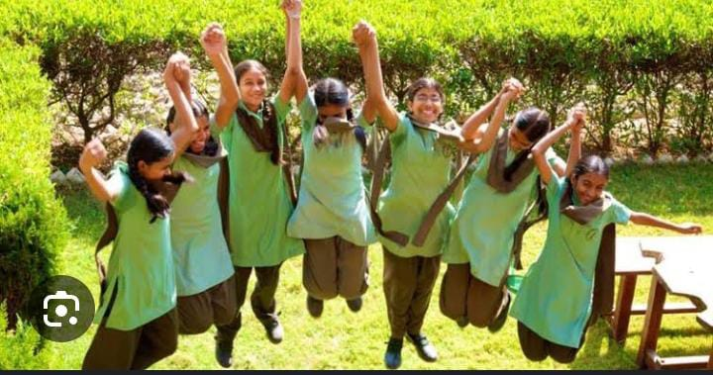

APPLICATIONS:-

Fabindia, as a well-known Indian retail brand specializing in traditional handcrafted products and clothing, finds various applications in different contexts. Some of the key applications of Fabindia are:

Fashion and Apparel: Fabindia offers a wide range of traditional and contemporary clothing options, including sarees, kurtas, tunics, and accessories. It caters to customers looking for ethnic wear with a touch of modernity.

Home Decor: Fabindia provides a diverse collection of home decor items, including furniture, textiles, rugs, cushions, and tableware. These products add a touch of traditional and artistic flair to homes and living spaces.

Gift Shopping: Fabindia's unique and handcrafted products make for thoughtful and meaningful gifts. Whether it's for festivals, weddings, or special occasions, their range of gift items appeals to a broad spectrum of customers.

Sustainable and Eco-Friendly Products: Fabindia's emphasis on traditional craftsmanship and sustainable practices attracts customers who are conscious of their environmental footprint and prefer eco-friendly products.

Interior Design and Architecture: Interior designers and architects may incorporate Fabindia products into their projects to create spaces that showcase Indian heritage and cultural aesthetics.

Wedding Trousseau: Fabindia's collection of wedding ensembles, accessories, and home decor items are popular choices for trousseau shopping, where brides and grooms stock up on items for their new life together.

Corporate Gifting: Fabindia's range of corporate gifts, such as handmade stationery, accessories, and customized products, can be used by businesses to gift clients and employees.

Promoting Indian Handicrafts: Fabindia plays a crucial role in promoting and sustaining traditional crafts and artisans across India by providing them with a platform to showcase their skills and products.

Cultural Representation: Fabindia's products represent various Indian cultures and traditions. They help individuals stay connected with their roots and heritage, especially those living away from their hometowns.

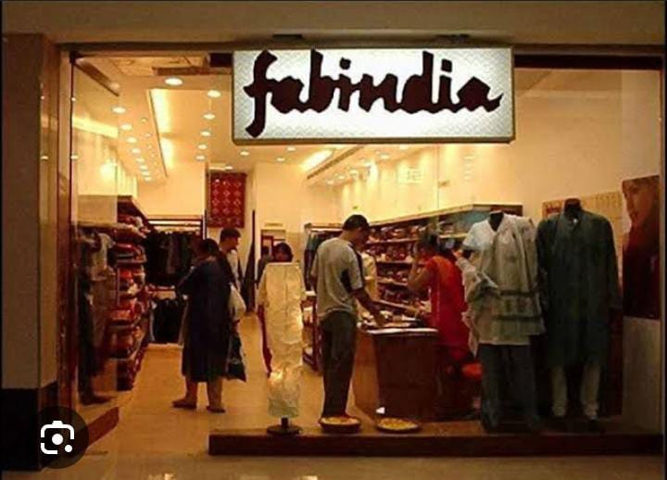

CONCLUSION:-

As an AI language model, I don't have access to real-time data or the ability to browse the internet beyond my last update in September 2021. As of my last update, Fabindia is a well-known Indian retail company that specializes in selling a wide range of handcrafted products, including clothing, accessories, home furnishings, and personal care items. They are known for promoting traditional Indian crafts and supporting rural artisans.

Without up-to-date information, I cannot provide a current conclusion for Fabindia. However, as of my last update, Fabindia was a successful and popular brand, and its commitment to promoting Indian heritage and craftsmanship had garnered a significant customer base both within India and internationally. Please note that it's essential to check more recent sources to obtain the most accurate and up-to-date conclusion about Fabindia and its current status in the market.

FUTURE SCOPE:-

International Expansion: Fabindia could explore further international expansion, reaching out to more countries and markets where there is an increasing interest in sustainable and ethically sourced products. The demand for authentic, handcrafted goods with a focus on cultural heritage is growing worldwide, and Fabindia's unique offerings could find a receptive audience in various countries.

E-commerce and Technology: Like many other retail brands, Fabindia could continue to invest in its e-commerce platform and leverage technology to enhance customer experience, reach a broader audience, and improve supply chain management. The online market offers significant potential for growth, and staying competitive in this space will be crucial.

Diversification of Product Range: Fabindia might consider expanding its product range to cater to evolving customer preferences and lifestyle changes. By introducing new product categories or collaborating with contemporary designers while staying true to its roots, Fabindia can attract a broader customer base and remain relevant in the changing market landscape.

Sustainability and Social Impact: Given the increasing global focus on sustainability and ethical business practices, Fabindia can continue to position itself as a socially responsible brand. Strengthening its commitment to fair trade practices, environmental stewardship, and community development can resonate with conscious consumers and contribute to its long-term success.

Collaborations and Partnerships: Collaborating with other like-minded brands, artists, or designers can bring fresh perspectives and creative ideas to Fabindia. Such partnerships can lead to innovative product lines and exciting marketing .

.